A Fraction as Part of a Set
Subject: Mathematics Creator: Alison Kimbley
Stand: Number Grade: 4
Content (topic)

Exploring Fractions
Outcomes  N 4.6: Demonstrate an understanding of fractions less than or equal to one by using concrete and pictorial representations to:  - Name and record fractions for the parts of a whole or a set  - Compare and order fractions.  - Model and explain that for different wholes, two identical fractions may not represent the same quantity provide examples of where fractions are used | Indicators  N 4.6c: Name and record the fraction for the included and not included parts of a set.  N 4.6e: Represent a fraction pictorially by indicating parts of a given set.
Mathematical Processes:
- Connections
- Communication
- Problem Solving
- Reasoning
- Visualization
Lesson Preparation
Equipment/materials:
- Graph paper, labeled A-E on the vertical axis and 1-4 on the horizontal axis with a picture of the Red River cart in the background. (See Appendix 1)

Advanced Preparation:
- Print the worksheets
- Print the pictures of the Red River carts onto graph paper
Presentation
Set
- Explain the history of the Red River Cart and show students the PowerPoint presentation.
Development
- Hand out the picture of the Red River cart and ask students to count the number of squares on the picture.
- Once students have determined that there are 20 squares, ask students to identify the squares that contain part of the cart. What fraction of the squares contains part of the car?
- After students have determined the fraction, ask the students to fill out the questions in the provided worksheet. (See Appendix B) The worksheet requires the students to examine the Red River cart in order to name and record fractions.

Appendix A

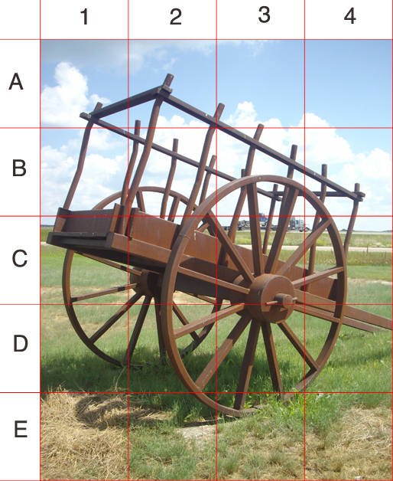

Appendix B
Red River Cart in Fractions (Worksheet)
- What fraction of the squares contains part of the closest wheel?

- Write the fraction that represents the amount of sky in the picture.

- Write a fraction, which represents the amount of grass in the picture.

- The Red River cart was a critical part of Métis history as it was the cart that carried buffalo carcasses after the bi-annual buffalo hunts. Can you determine a fraction of something from the picture that is different from the fractions you found in questions 1-3?

